**ASSIGNMENTS ON DIGITAL MARKETING**

**NAME:** KEVIN GIFTSON I

**DEPARTMENT:** BE BIOMEDICAL ENGINEERING

**COLLEGE:** 8151 DHANALAKSHMI SRINIVASAN INSTITUTE OF

TECHNOLOGY

**NAANMUDHALVAN COURSE**: DIGITAL MARKETING

**NM ID:** A5649022567F9FBB3CF4AAE0E20078A9

**ASSIGNMENT 1:**

Create a blog or website using Blogspot and WordPress. Customize

The theme design and post new article with 500 words.

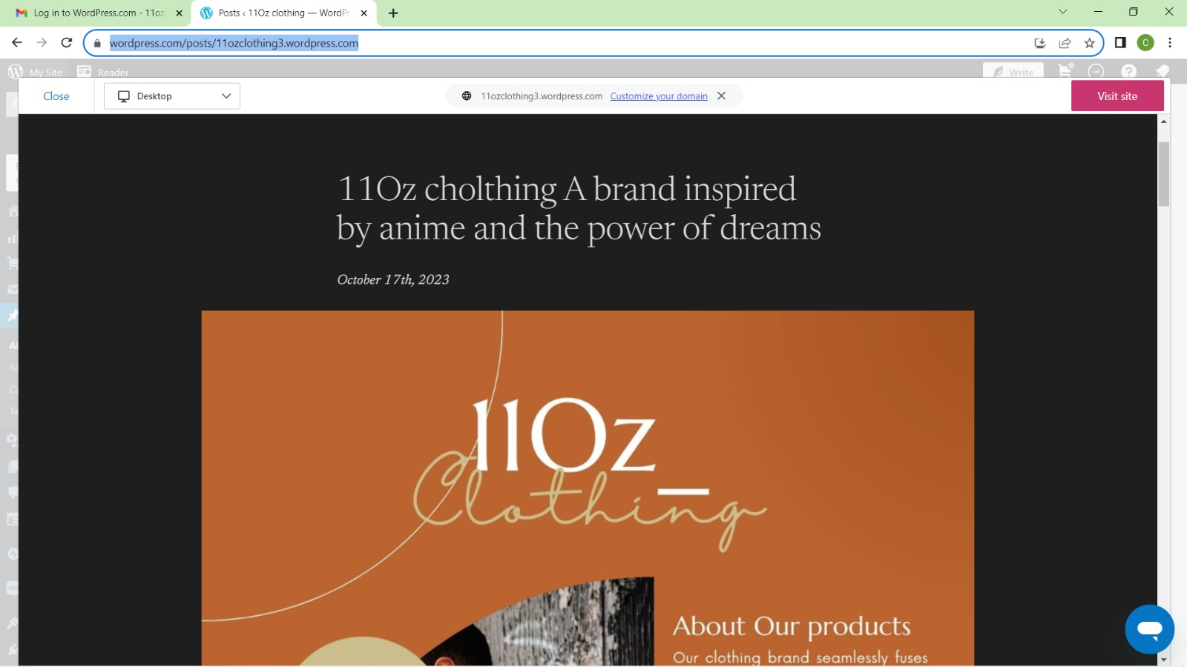 <https://wordpress.com/posts/11ozclothing3.wordpress.com>

**ASSIGNMENT 2:**

Create a new Facebook business Page and Post one social media poster for your brand.

<https://www.facebook.com/profile.php?id=61550852877993&mibextid=ZbWKwL>

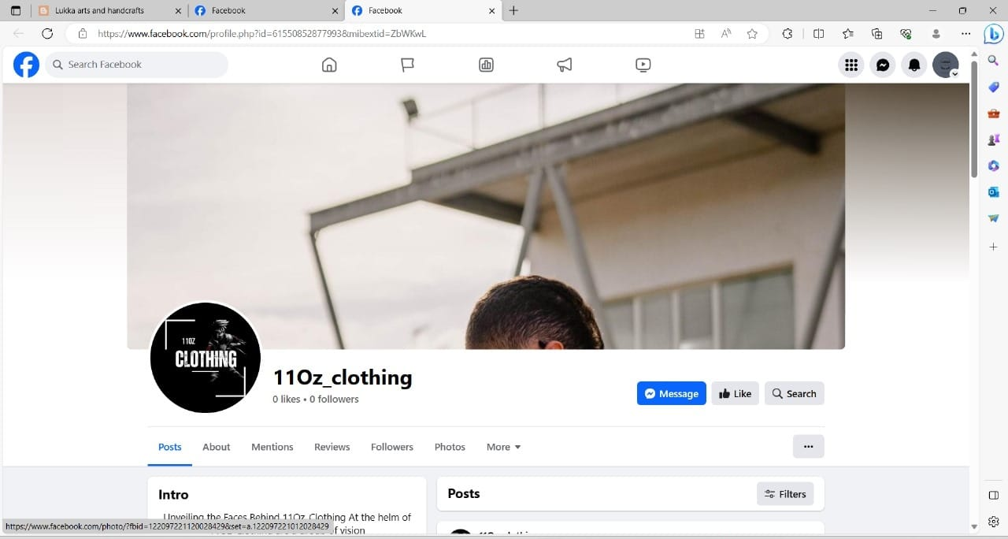

**ASSIGNMENT 3:**

Create and design a social media advertisement poster using Canva.



**ASSIGNMENT 4:**

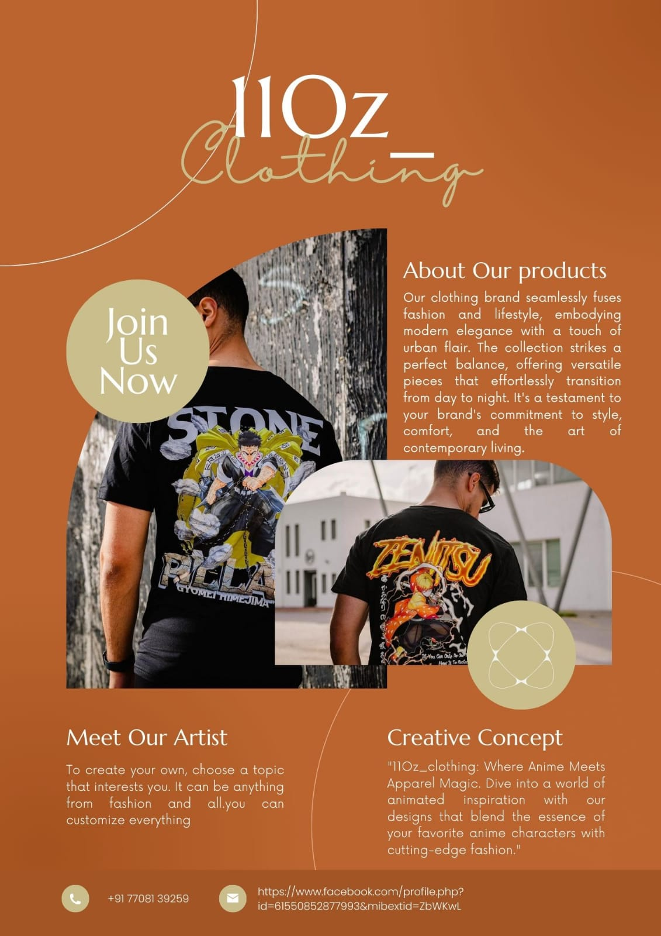4.Create email newsletter design using MailChimp or Canva tool.